Revision History
Date | Version | Description | Author
09.03.2014 | 0.1 | First Implementation of SDP | Alp Kaan Erer, Can Şahin, Burcu Başak Sarıkaya, Fırat Emre Met, Eray Tunçer
10.03.2014 | 0.2 | Risk Assessment & Software Development Activities Revised | Alp Kaan Erer, Can Şahin, Burcu Başak Sarıkaya, Eray Tunçer

TABLE OF CONTENTS

Revision History 1
1 Identification 3
1.1 Document overview 3
1.2 Abbreviations 3
1.2.1 Abbreviations 3
1.3 References 3
1.3.1 Project References 3
2 Software Development Activities 3
2.1 Software development process 3
2.1.1 Overview of process phases 3
2.1.2 Technical documentation 4
2.1.3 Deliverables: 4
2.2 Software development tools 4
2.2.1 Workstation 4
2.2.2 Requirements management and documentation 4
2.2.3 Software Design 4
2.2.4 Coding and automated tests 4
2.2.5 Configuration management 4
2.3 Software development rules and standards 4
3 Responsibilities 5
3.1 Activities and responsibilities 5
4 Risk Assessment 6
4.1 Risk Analysis 6
4.2 Risk Planning 6

Identification

Document overview
This document contains the software development plan of Block Breaker game.

Abbreviations

Abbreviations
GUI | Graphical User Interface
SDP | Software Development Plan
SRS | Software Requirements Document
STP | Software Test Plan
SDD | Software Design Document
STR | Software Test Report

References

Project References

# | Document Identifier | Document Title

Software Development Activities
This section lists and describes the software development activities of Block Breaker game.

Software development process
The software development process chosen for the project is the waterfall programming model.

Overview of process phases
The lifecycle of the software development project is composed of:
- Determining the software specifications
- Software detailed design
- Software development(software coding)
- Software verification & validation(unit tests)

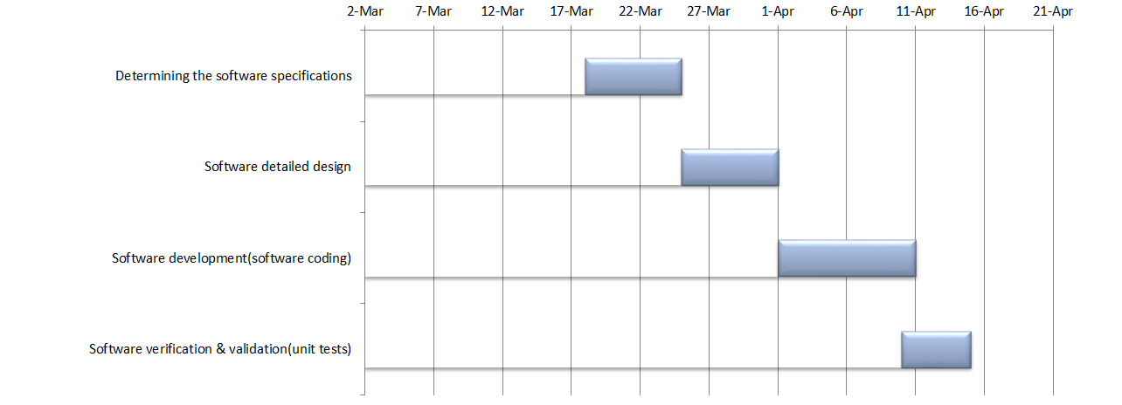

Technical documentation
The following documentation is produced during the design phases:
- Software Development Plan (SDP)
- Software Requirements Document(SRS) & Software Test Plan(STP)
- Software Design Document(SDD)
- Coding, implementation
- Software Test Report(STR) & Report

Deliverables:
The following items are delivered at the end of the process:
- Technical documents: SDP, SRS, STP, SDD, STR
- Demo, Working System
- GitHub Records
- Project Page
- Bugs and issues
- Time tracking, contributions, commit history

Software development tools

Workstation
A typical notebook that has an Intel Core i7 processor and runs Windows 7 Operating System will be used as our workstation.

Requirements management and documentation
- Microsoft Word for documentation
- Microsoft Excel for charts

Software Design
- Microsoft Visio for UML diagrams.
- Adobe Photoshop for software images

Coding and automated tests
- Eclipse Kepler for coding
- JUnit for tests

Configuration management
- Git, Github(https://github.com/ErayTuncer/OZU-CS320-JUNIORS), TortoiseGit
- Github issues for keeping a record of the status of bugs & issues.

Software development rules and standards
Oracle Code Conventions for the Java Programming Language will be used as a coding standard in this project.

Responsibilities

Activities and responsibilities

Activity | Responsibility | Comment
Project manager | Alp Kaan Erer | Organize group members, schedule meetings and ensures that project is meeting its deadlines.
Software Developer | Can Şahin | Keeps track of group members software development process
Software Test Engineer | Eray Tunçer, Burcu Başak Sarıkaya | Test the software via unit tests
Software & GUI Design | Fırat Emre Met | Design software visuals and UML diagrams

Risk Assessment

Risk Analysis

Risk | Probability | Effects
The time required to develop the software is underestimated | Moderate | Serious
The time required to test the software is underestimated | Moderate | Tolerable
A change in customers’ demands | Moderate | Serious
Some group member leaves from project | Low | Tolerable

Risk Planning
Risk | Potential Indicators
The time required to develop the software is underestimated | Late delivery of software, unimplemented classes, methods.
The time required to test the software is underestimated | Although software is ready, unit tests are not implemented
A change in customers’ demands | Customer wants to make changes during the process.
Some group member leaves from project | Group member can leave the project due to his/her private issues.

Risk | Strategy
The time required to develop the software is underestimated | There will be no tolerance to the delays in the schedule. If the deadline cannot be met then individual workloads will be increased to meet the schedule immediately. This will be handled by reorganizing the duties of the group members. In the extreme cases a deadline extension can be asked.
The time required to test the software is underestimated | Testing the software will not be postponed to the end of the project (after software implementation is done).  Reorganize group members to intensively help software test engineers to meet the deadline.
A change in customers’ demands | There will be strict policy for changes during the project process. Customer will not be allowed to demand major changes in software.
Some group member leaves from project | Reorganize remaining group members to handle the job of the dropped out member. In an extreme case, assist from another person can be thinkable.

